Population(millions) of Chittagong
in 2050 under SSP2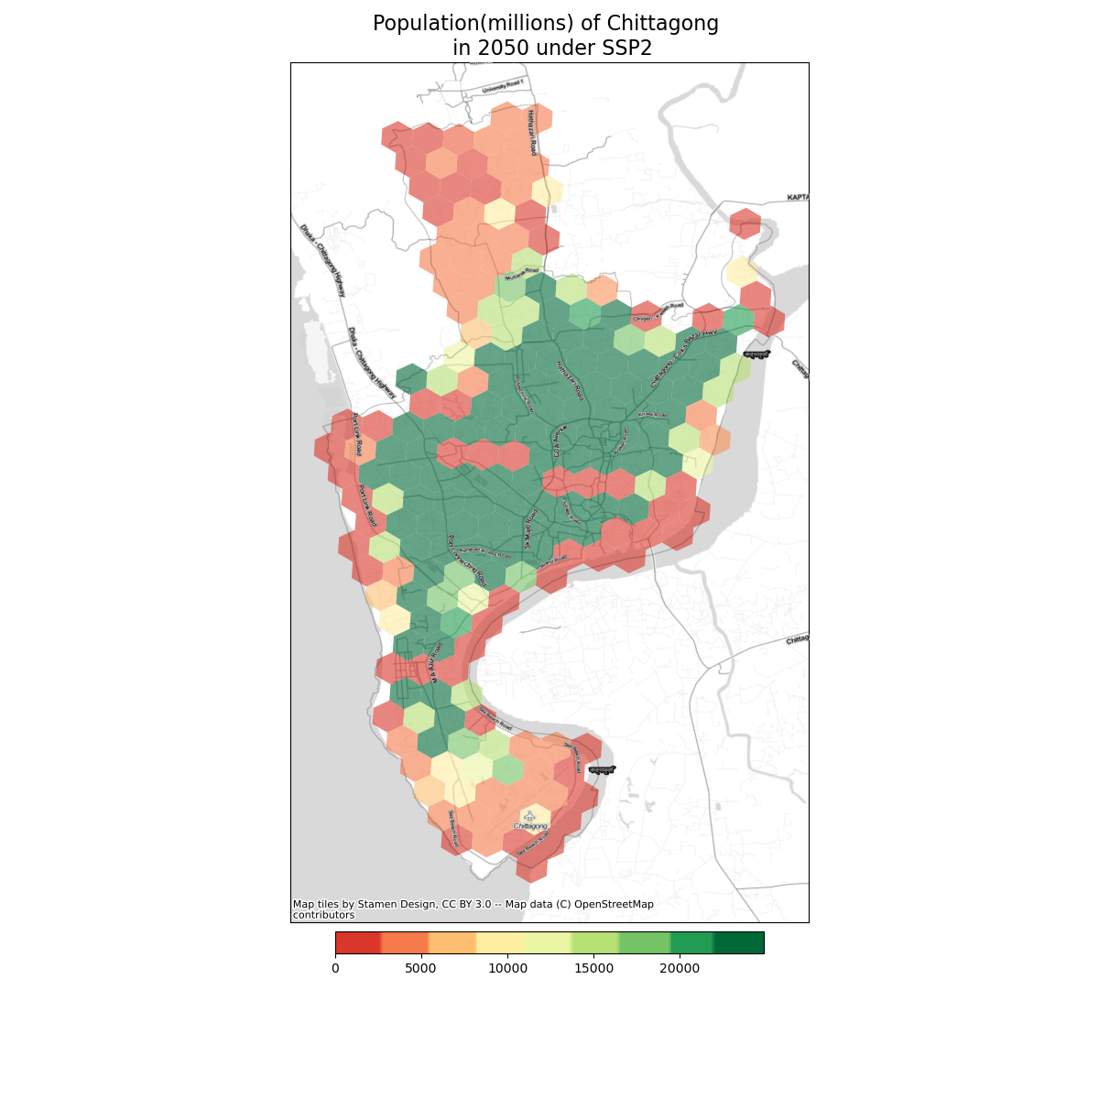Notes here
Population(millions) of Chittagong
in 2100 under SSP2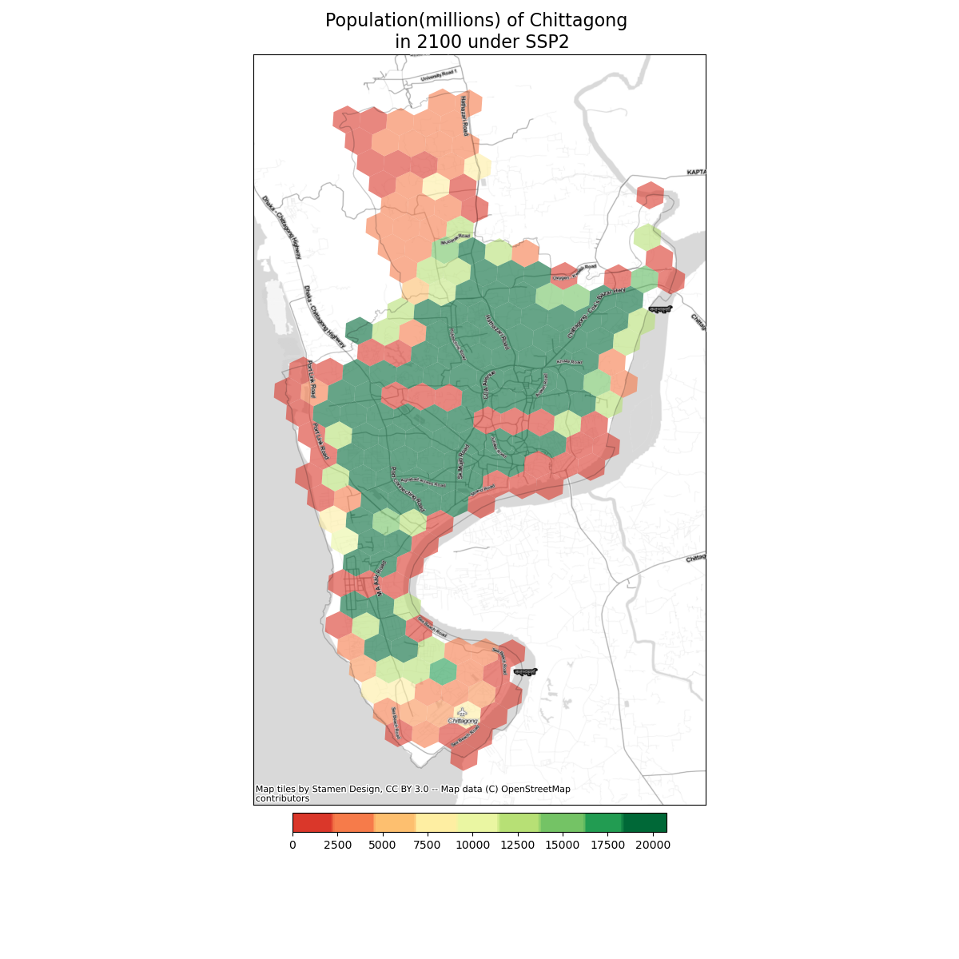Notes here
Population(millions) of Chittagong
in 2050 under SSP5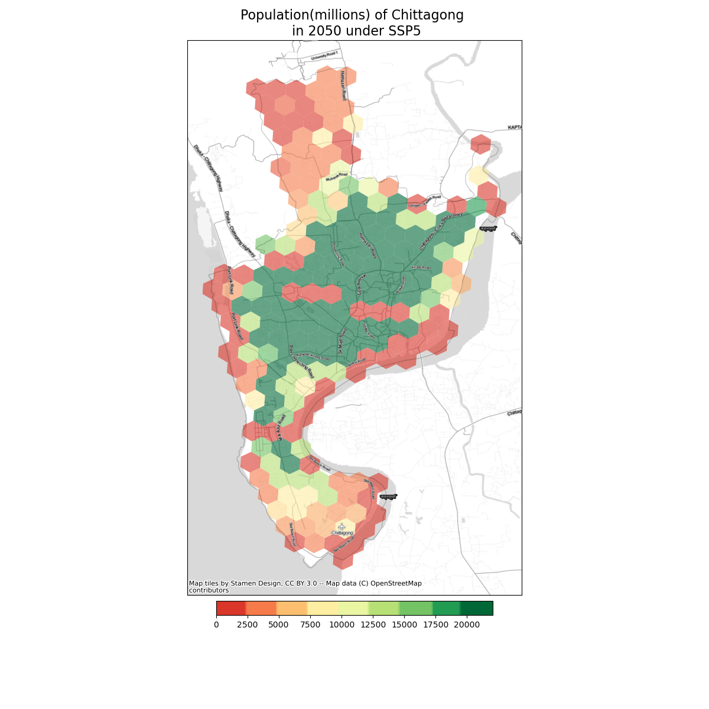Notes here
Population(millions) of Chittagong
in 2100 under SSP5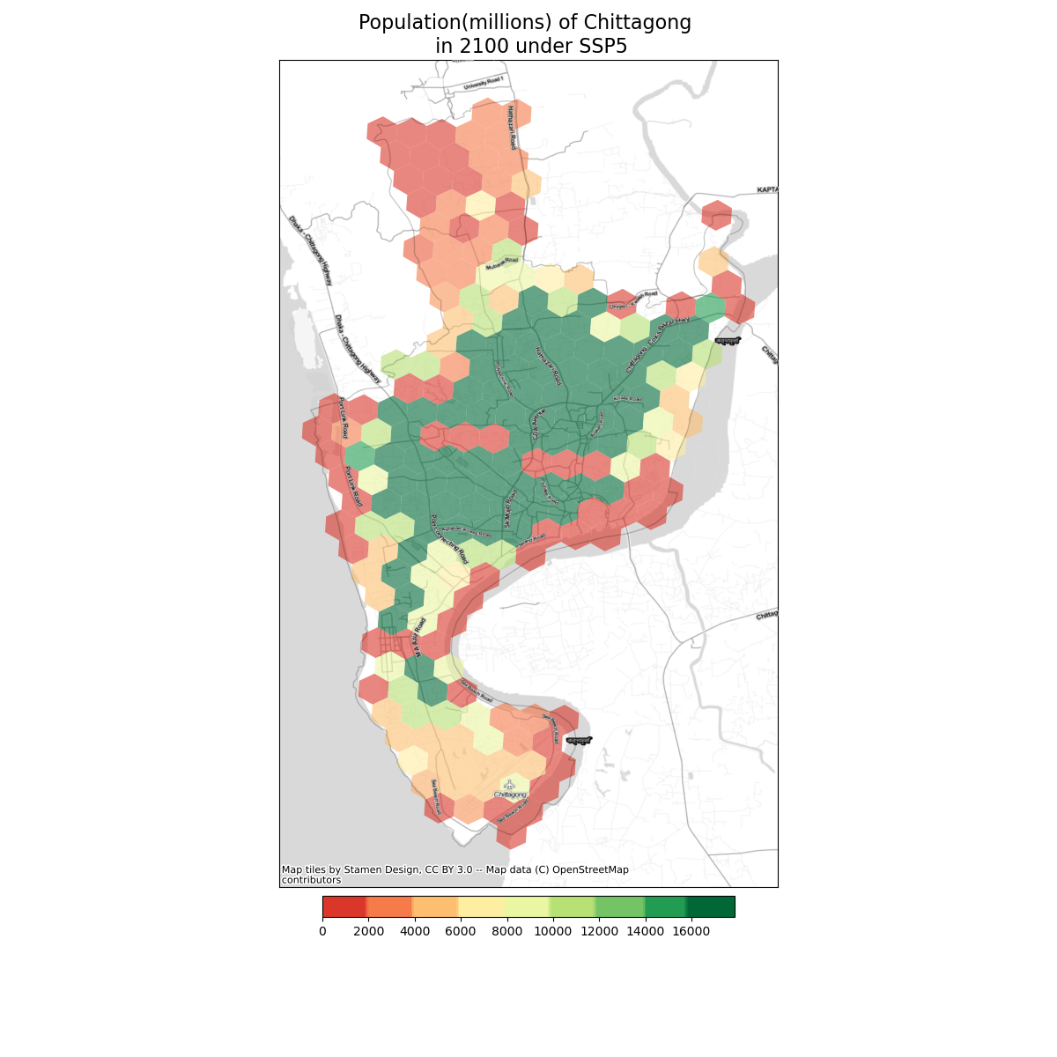Notes here

